# CODING & SOLUTIONING

# FEATURE 1:

As a user before using any website they bringing that website into our

project URL and typing it . As the user types,it results whether it is a safe website or unsafe website in that porject URL so that before they entering into that website and giving thier personal information they may get aware of usage of that particular website to prevent the fake websites to be used by the user .By entering the website it predicts the safe or unsafe website.

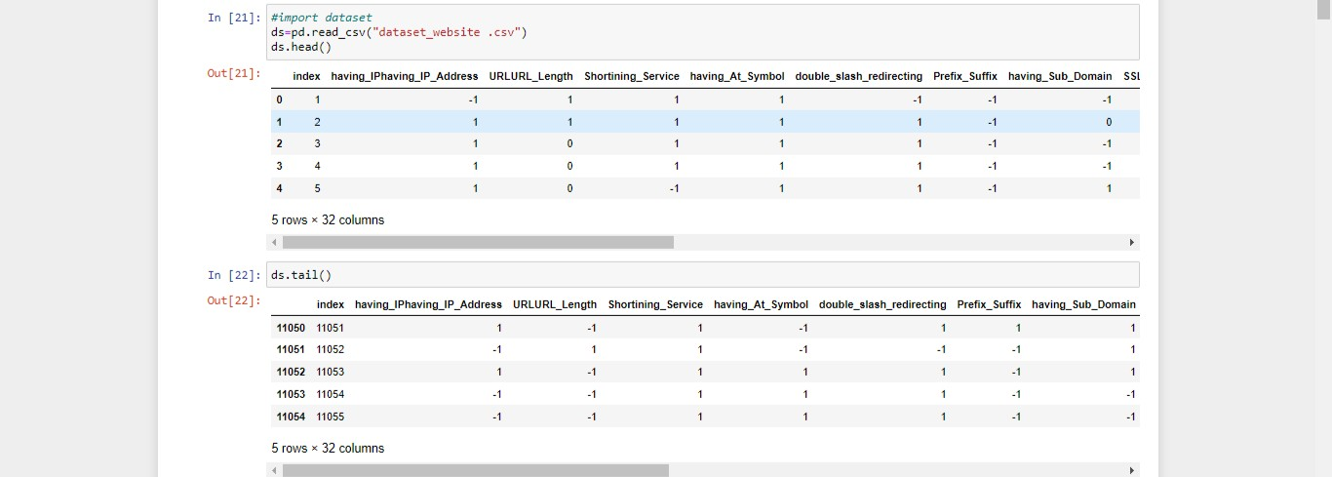

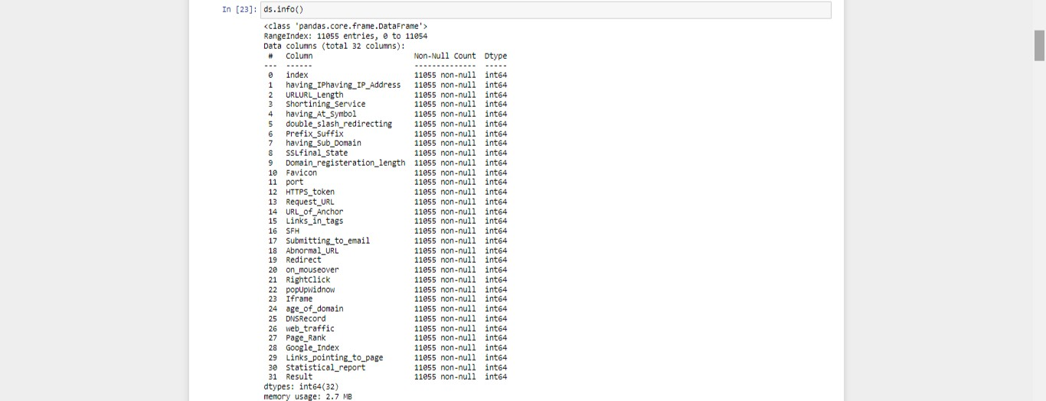

# FEATURE 2:

Here the user enters the URL in our project workspace, it predicts the safe or unsafe website in which the user will get alert of entering into that website as it alerts with a wordings namely **"it is safe website,and it is secure! or it is an unsafe website be cautious!".**By displaying the message user will surely be alert of using the website.

